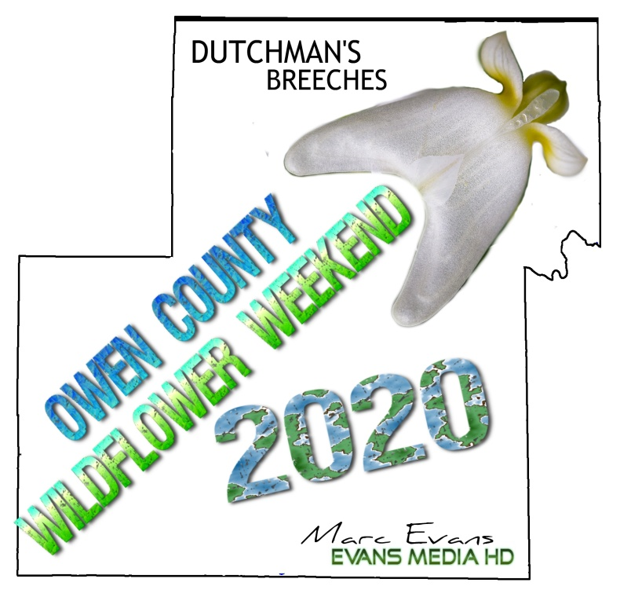
Owen County Wildflower Weekend
April 17-19, 2020

Wildflower Hikes at McCormick’s Creek State Park
(With the Best plant lovers on earth)

Friday Kickoff event!
Plant diversity at Fish Creek Preserve
(With Sycamore Land Trust and the Indiana Native Plant Society)

Weed Wrangle for Natives!
(With Amber Slaughterbeck and the Sweet Owen Woodlands Network)

Building a “Monarch Waystation”
At the MYPath Trail
(Saturday at 3pm)

Saturday Evening Dinner!
(at the Canyon Inn, MCSP, No RSVP needed)

GET A FULL BROCHURE FROM THE NATURE CENTER or SWCD OFFICE.
QUESTIONS- CALL 812-829-4344 or 812-829-2605.

